**GUI for CURRENCY CONVERTER**

END-TERM REPORT

**BACHELOR OF TECHNOLOGY**

**in**

**COMPUTER SCIENCE AND ENGINEERING**

By:

|  |  |  |  |
| --- | --- | --- | --- |
| *S.no.* | *Name* | *Roll No.* | *Registration no.* |
| *1.* | *Suddapalli Gangadhar* | *29* | *11904126* |
| *2.* | *Koyya Gopal Sai* | *31* | *11904320* |
| *3.* | *Muddada Venkata Sai Prasad* | *26* | *11904281* |

**Courses Code: INT213**

**School of Computer Science and Engineering**

Lovely Professional University

Phagwara, Punjab (India)

**Introduction**

A currency converter is programming code that is designed to convert one currency into another in order to check its corresponding value.

Currency Converter is a calculator or a software or a tool that converts quantity or value of one currency into the relative quantities or values of other currencies to check its corresponding value such as dollars to euros. It is an electronic program that allows for the quick conversion of currencies. Converters use the most recent prices to convert in the foreign exchange market. When currency converters use online it is usually free of charge. It stores the most recent market valuations of the world’s currencies which allows individuals to compare the value of one currency against those of others in the database.

Currency Conversion can also be determined by contacting a local bank and asking for exchange rates. Main aim for this currency converter is to maintain real-time information on current market or bank exchange rates, So it will be helpful to calculate changes of the result whenever the value of either of the component currencies does.

Currency converters aim to maintain real-time information on current market or bank exchange rates, so that the calculated result changes whenever the value of either of the component currencies does. They do so by connecting to a database of current currency exchange rates. The frequency at which currency converters update the exchange rates they use varies: Yahoo currency converter updates its rates every day.

Currency converters usually display a value that is not biased towards buying or selling. This is useful when:

1.Estimating the value of goods or services

2.Basic accounting and invoicing

3.Preparing financial plans and reports

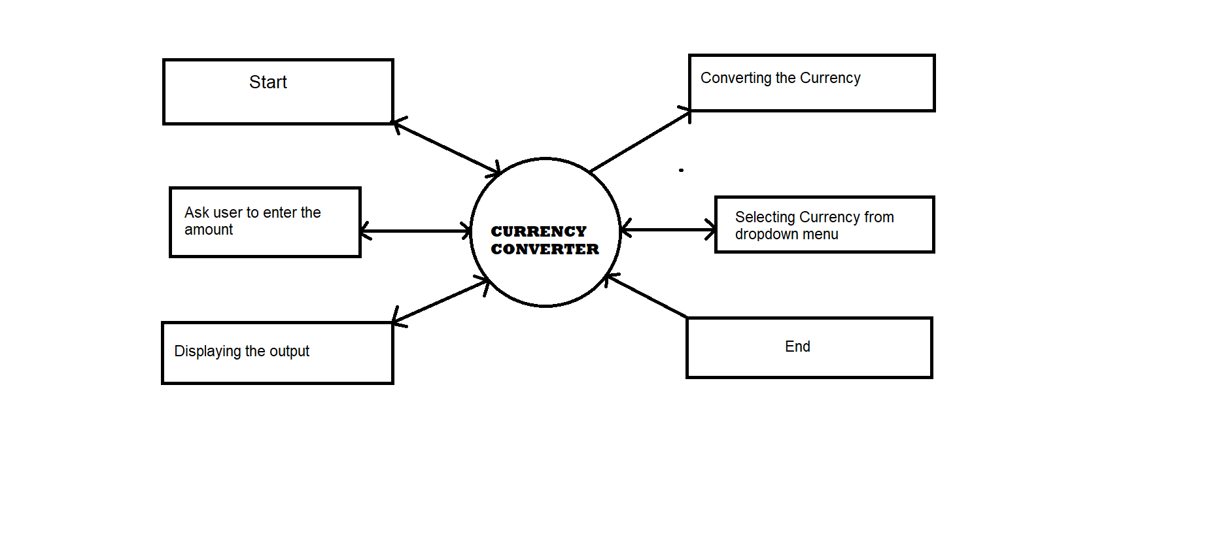**DFD DIAGRAM :**

**ER DIAGRAM:**

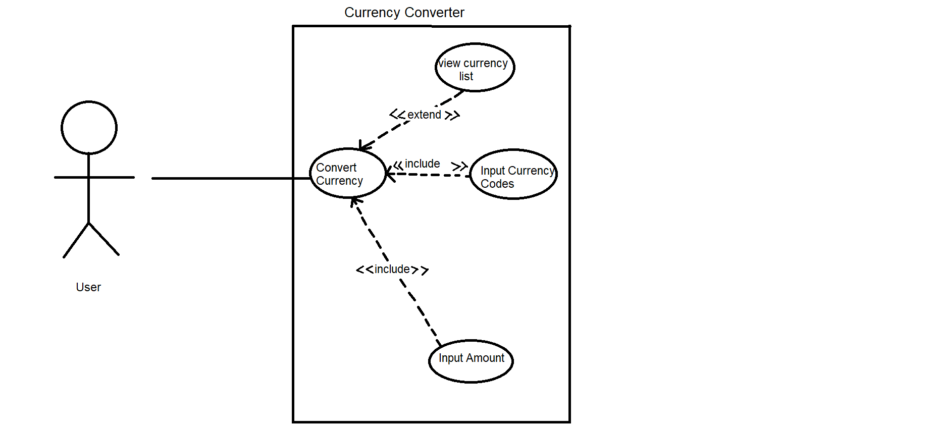

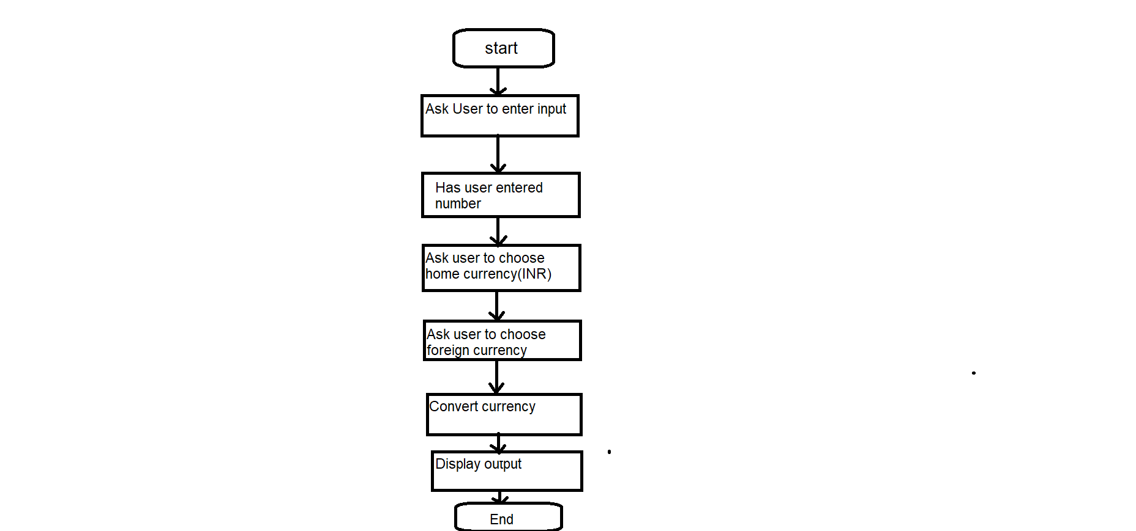**Flow chart:**

**GUI Screenshots:**

**1.WELCOME SCREEN:**

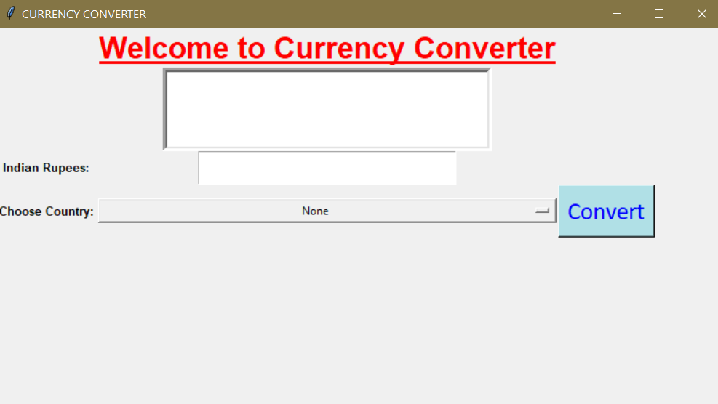

**2.CURRENCY CONVERTER**(*with input values*)

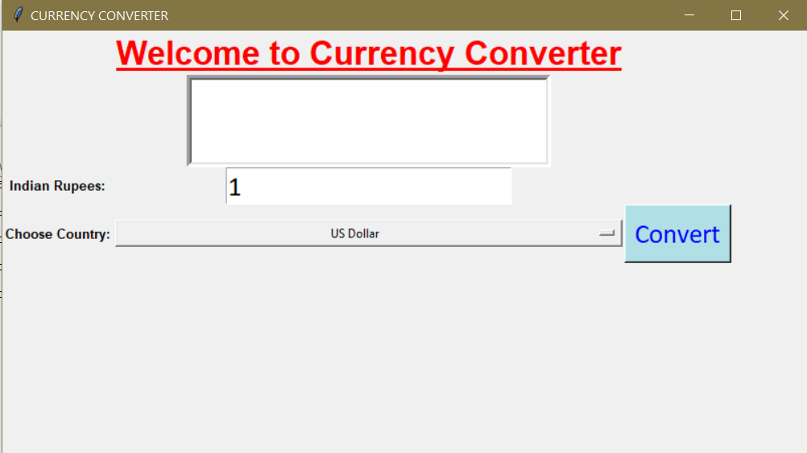

**3. CURRENCY CONVERTER** (*with output values*)

